# Buywill System

### 引言

一个在线购物系统，用户通过该系统可以买任何想买的东西

### 需求描述

**Web客户端**：用户可以购买商品，将商品加入购物车中，用户可删除购物车内容，或直接下单，用户可以查看购买的商品和订单信息。

**应用程序端**：管理员可以查看订单信息并控制发货。

### 系统设计

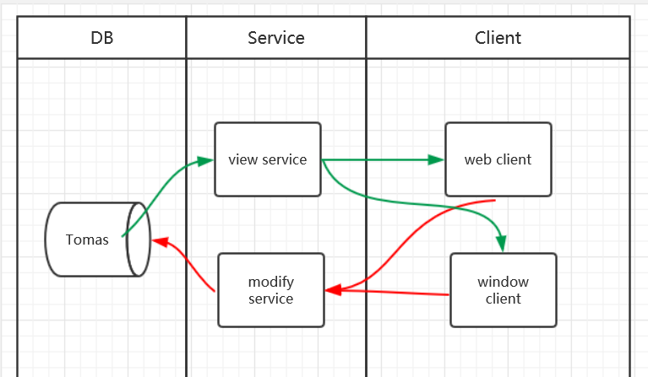

### 功能模块

**WebClient**：支持用户购买商品，查看购物车和订单信息

* BuyUI：支持用户添加商品到购物车

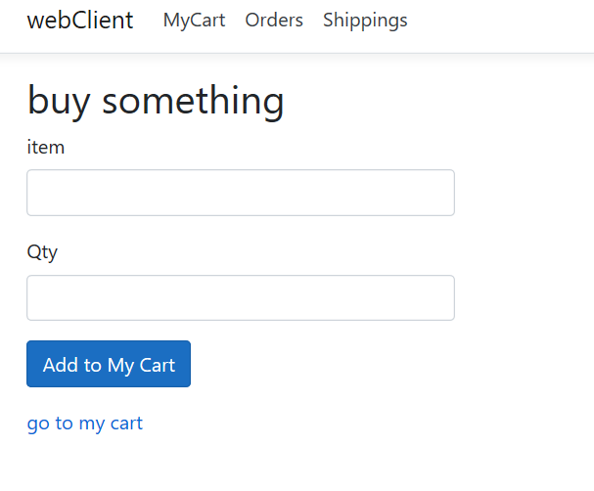

* CartUI: 用户查看删除购物车的内容，或者直接付款

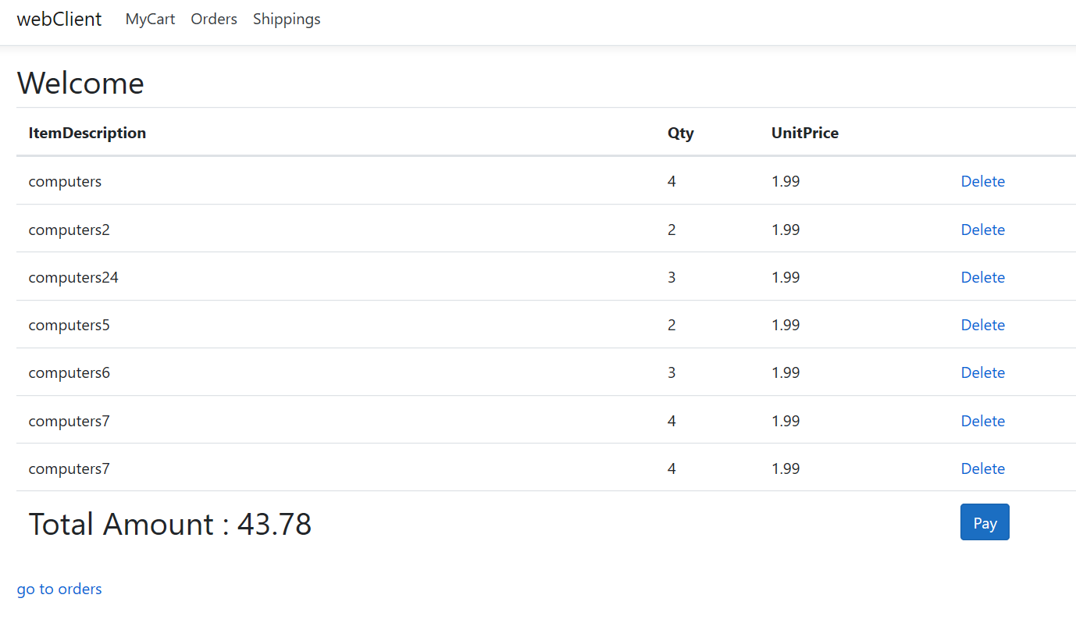

* OrderUI：用户查看订单信息

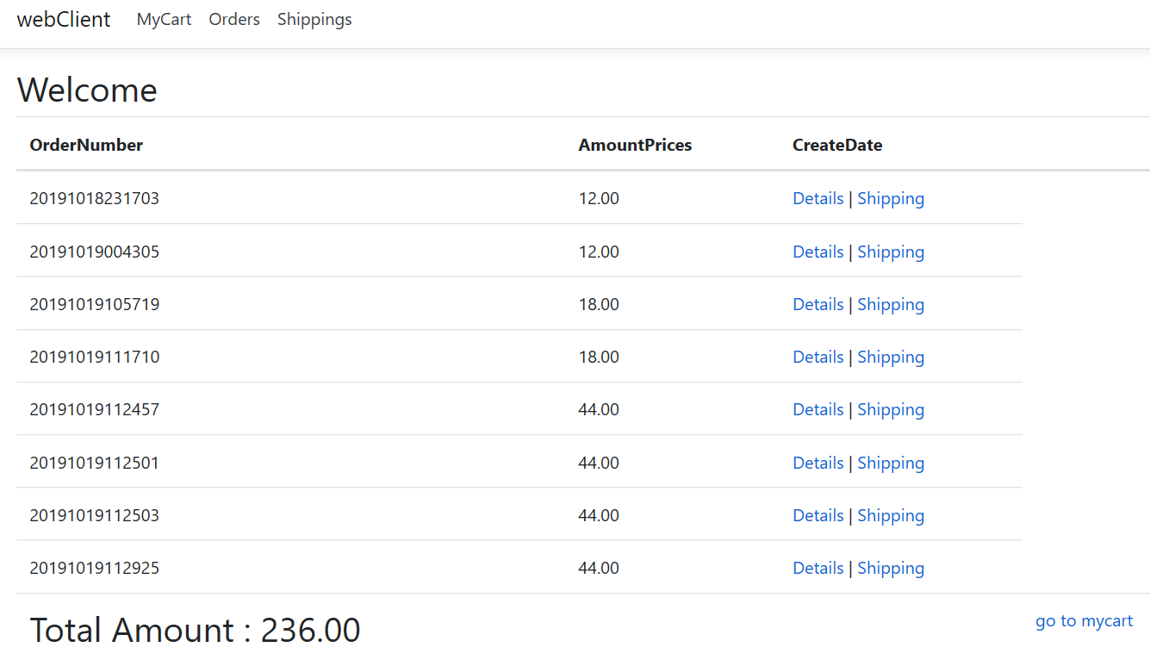

* ShippingUI：用户查看发货信息。

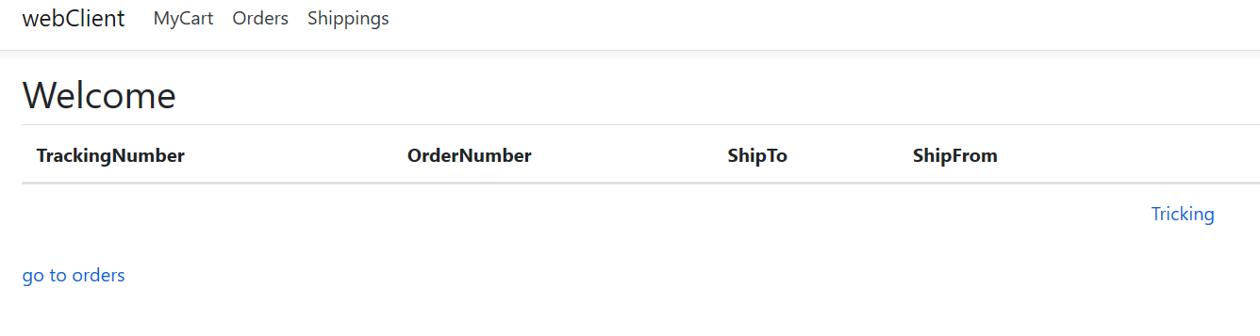

**WindowClient**：支持管理员查看订单信息，并控制发货。

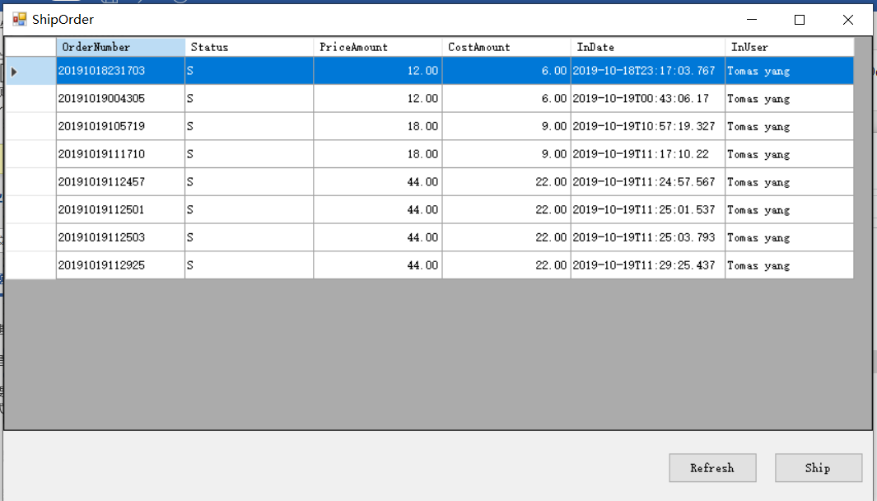

### 接口设计

**ViewService**：提供数据查询服务。

|  |  |  |
| --- | --- | --- |
| Uri | Method | 描述 |
| /cart/list | Get | 查看购物车 |
| /order/list | Get | 查看订单 |
| /shipping/list |  | 查看发货信息 |
|  |  |  |

：

**ModifyService**：提供数据写入服务。

|  |  |  |
| --- | --- | --- |
| Uri | Method | 描述 |
| /cart/add | Post | 添加到购物车 |
| /cart/delete | Delete | 删除购物车： |
| /order/addToOrder | Post | 付款生成订单 |
| /order/UpdataOrder | Put | 发货 |

### 数据库设计

**Tomas_Cart**

|  |  |  |  |  |
| --- | --- | --- | --- | --- |
| **Key** | **Field Name** | **Data Type** | **Req** | **Remark** |
| PK | TransactionNumber | int | X | IDENTITY(1,1) |
| IX | UserID | Varchar(50) | X | Fixed Tomas |
| IX | ItemNumber | Varchar(50) | X |  |
|  | ItemDescription | Varchar(200) | X |  |
|  | UnitPrice | Decimal (12,2) | X | Order price amount |
|  | Cost | Decimal (12,2) | X | Order cost amount |
|  | Qty | Int | X |  |
|  | InDate | DateTime | X |  |
|  | InUser | Varchar(15) | X |  |
|  | LastEditDate | DateTime |  |  |
|  | LastEditUser | Varchar(15) |  |  |

**Tomas_OrderMaster**

|  |  |  |  |  |
| --- | --- | --- | --- | --- |
| **Key** | **Field Name** | **Data Type** | **Req** | **Remark** |
| PK | TransactionNumber | int | X | IDENTITY(1,1) |
| IX | OrderNumber | Varchar(50) | X |  |
| IX | Status | Char(1) | X | I: init  S:Shipped  V:Void  C:Close |
|  | PriceAmount | Decaiml(12,2) | X | Order price amount |
|  | CostAmount | Decaiml(12,2) | X | Order cost amount |
|  | InDate | DateTime | X |  |
|  | InUser | Varchar(15) | X |  |
|  | LastEditDate | DateTime |  |  |
|  | LastEditUser | Varchar(15) |  |  |

**Tomas_OrderTransaction**

|  |  |  |  |  |
| --- | --- | --- | --- | --- |
| **Key** | **Field Name** | **Data Type** | **Req** | **Remark** |
| PK | TransactionNumber | int | X | IDENTITY(1,1) |
| IX | MasterTransaction | Int | X | Transaction number in orderMaster |
| IX | ItemNumber | Varchar(50) | X |  |
|  | ItemDescription | Varchar(200) | X |  |
|  | UnitPrice | Decimal (12,2) | X | Order price amount |
|  | Cost | Decimal (12,2) | X | Order cost amount |
|  | Qty | Int |  |  |
|  | InDate | DateTime | X |  |
|  | InUser | Varchar(15) | X |  |
|  | LastEditDate | DateTime |  |  |
|  | LastEditUser | Varchar(15) |  |  |

**Tomas_Shipping**

|  |  |  |  |  |
| --- | --- | --- | --- | --- |
| **Key** | **Field Name** | **Data Type** | **Req** | **Remark** |
| PK | TransactionNumber | int | X | IDENTITY(1,1) |
| IX | ShippingNumber | Varchar(50) | X |  |
| IX | TrackingNumber | Varchar(50) |  |  |
| IX | OrderNumber | Varchar(50) | X |  |
|  | ShipTo | Varchar(500) | X | address of Ship to |
|  | ShipFrom | Varchar(500) | X | address of Ship from |
| IX | Status | Char(1) | X | I: init  S:Shipped  T:Tracking |
|  | InDate | DateTime | X |  |
|  | InUser | Varchar(15) | X |  |
|  | LastEditDate | DateTime |  |  |
|  | LastEditUser | Varchar(15) |  |  |